A Review on Various Methodologies for Asteroid Deflection

Abstract:

Asteroid impacts could have disastrous effects on Earth, thus defense against them has drawn a lot of attention. This paper provides a thorough evaluation of potential asteroid impact mitigation technology and defense measures. The project examines strategies for asteroid deflection and redirection or destruction, as well as detection and tracking techniques for near-Earth objects (NEOs). Some of the methods looked at include solar sails, gravity tractors, explosive fragmentation, and kinetic impactors. Considerations including warning time, asteroid composition, and mission logistics are taken into account as well as the effectiveness, viability, and potential difficulties of any approach. In order to improve early detection and reaction capabilities, the article also highlights the value of international coordination and collaboration in building a global defense network.

**Keypoints:** Near-Earth Objects (NEOs), Potentially Hazardous Asteroids (PHAs), Double Asteroid Redirection Test (DART)

Introduction:

Earth is frequently bombarded by meteors, and occasionally, these meteors can be large enough to cause significant explosions and potential loss of life. While it is not feasible to detect all hazardous asteroids, the progress in identifying them well in advance of potential impact is relatively slow. Similarly, efforts to develop strategies for mitigating the danger posed by asteroid impacts through asteroid deflection are still in their early stages of development.

Although the likelihood of a deadly asteroid strike in the next century is low, the most probable impact would involve a relatively small asteroid. Therefore, we propose that the most effective short-term mitigation strategy would be to simply relocate people out of harm's way. With sufficient warning, a small asteroid impact should not result in loss of life, and even portable property could potentially be preserved. We outline an early warning system that could provide approximately one week's notice for most significant asteroids or comets on a trajectory towards Earth. This approach may suffice as the required mitigation measure for small asteroids and can be implemented immediately at a relatively affordable cost.(Weisbin et al., 2015)

Literature Review:

Over the years, the focus on planetary defense has increased as our understanding of the space environment expands, and the risks associated with small and medium impacts become more apparent. Events like the Chelyabinsk meteor and the Tunguska impact, among others, serve as powerful reminders of the significance of research and efforts in planetary defense. The majority of potentially hazardous asteroids (PHAs), with approximately 5000 objects identified so far, fall within the diameter range of 50 to 200 km. Various mitigation techniques have been extensively studied, offering immediate options for implementation. Among the most promising technologies are energetic explosion, gravity tractor, kinetic impactor, and directed energy approaches. Out of these options, the kinetic impactor stands out as a versatile choice that can be employed across a wide range of warning times and demonstrates higher effectiveness for PHAs within the diameter range that represents the majority of such objects.(Wie, 2012)

1. NASA Double Asteroid Redirection Test (DART):

In November 2021, the DART mission was launched to demonstrate the kinetic impactor technique. The target destination of the mission was the Didymos asteroid system, which consists of the 750-meter diameter Didymos asteroid and its 150-meter moon Dimorphos. This system does not pose a risk of impacting Earth. The deliberate impact of DART on Dimorphos resulted in a reduction of its orbital period around Didymos by approximately 30 minutes. This alteration is visually represented in schematic demonstrations. Images captured by the DART spacecraft revealed that Dimorphos comprises a varied assemblage of rocks ranging in size from centimetres to tens of meters. These rocks are intertwined but form a remarkably smooth overall shape when compared to other asteroids that have been explored by space probes.(Rivkin & Cheng, 2023)

**Schematic representation of the DART mission**

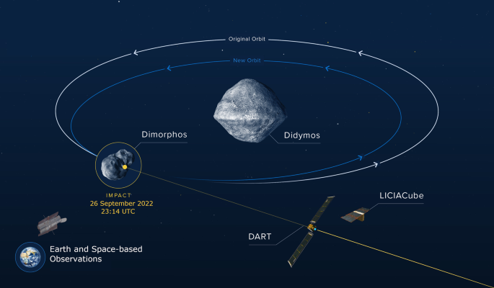

In order to deflect asteroids, the DART mission used a method called a "kinetic impactor," which simply means to crash one object into another.

**DART low-thrust spacecraft design**

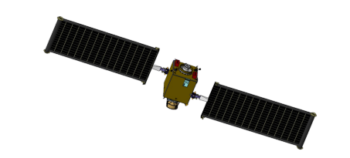

Earlier a set of DART trajectories were finalsed using a monopropellant hydrazine-powered spacecraft. These trajectories, which had three launch windows, were effective in achieving the mission's goals. Less than 100 m/s of velocity change was necessary for the spacecraft's simple design to reach the target. This concept, however, required a specific launch vehicle with a launch C3 (characteristic energy) of roughly 6 km2/s2. In comparison to the spacecraft's total modest cost, the cost of the necessary launch vehicle was excessive. Additionally, only a small percentage of the launch circumstances, roughly one in four chances, permitted DART to complete an intermediate asteroid flyby, which is a need for the mission's risk-reduction strategy.(Capannolo et al., 2021)

**Timeline of potential DART trajectories within launch period (top) and current baseline reference (bottom)**

The desired target arrival conditions, specifically the direction of DART's velocity at impact, could only to a limited extent be controlled by the impulsive-thrust trajectories. This lack of control caused uncertainty in the anticipated arrival conditions because of our poor understanding of the Didymos binary system's shape. Furthermore, Didymos's favourable viewing geometries are sporadic, making it difficult to have a complete grasp of the binary system's geometry before launch. This ignorance makes it harder to completely guide the design of the spacecraft and the AIDA experiment.

**DART Colliding with Dimorphos**

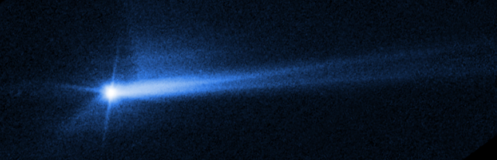

1. Ion Beam Shepard (IBS) :

Technically speaking, it is possible to divert an asteroid away from our planet's path of destruction in a variety of ways. The main idea is to send the asteroid a deflecting impulse that will eventually have the effect of shifting the asteroid's intersection point on the Earth's b-plane by an amount large enough to confidently rule out an impact with our planet.

According to this idea, a continuous stream of laser beams is fired at the target asteroid by a collection of phase-locked laser amplifiers that are positioned around 1 km away. The asteroid's surface material is expelled from the asteroid after the laser spot's temperature is sufficiently raised by the focused energy.

Depending on whether the laser leads or follows the asteroid in its course, the reaction force produced by the expelled vaporisation plume causes the asteroid's velocity to change.

A stand-off nuclear explosion or just a spacecraft colliding with it at high relative velocity can both instantly deliver such an impulse. The latter technique, sometimes known as a kinetic impactor (KI), is one of the most popular asteroid deflection techniques, largely because the NASA Deep Impact mission successfully tested it in 2005. In that mission, a 370-kg impactor slammed into the P/Tempel 1 comet's nucleus at a relative velocity of 10.3 km/s. Although the comet mentioned above is around 40 times smaller than the average 150 m diameter asteroid, striking at a similar speed would nonetheless necessitate significant advancements in the fields of guidance and navigation.(Bombardelli et al., 2013)

1. Nuclear Explosives

The velocity perturbation needed to prevent an impact with decades of notice is between millimetres and centimetres per second, while a little more may be preferred for a pleasant miss. It is plausible to believe that the impulse causing such modest velocity perturbations would not cause fragmentation or excessive ablation for large entities (500 m to 1000 m), as the required speed variation is significantly less than the 25–50 cm/s escape velocity . These conditions have been satisfied in thorough hydrodynamic simulations presented at previous Planetary Defence Conferences . A quick summary of these earlier studies on standoff and extremely low yield surface bursts is provided in the following section.(Syal et al., 2013)

It is desirable to establish the boundaries of nuclear explosives' location within the spectrum of mitigation technologies that are now accessible. The difficulty in foreseeing an asteroid's reaction rests in the ambiguity of its structures, just like the outputs of nuclear explosives are widely known. NEOs are a wide group of objects, ranging in size from metres to kilometres and in rotational speed from negligible to almost breaking up. The forms range from almost spherical to elongated, asymmetrical morphologies, and densities and porosities are widely varied. The best way to employ nuclear weapons against huge bodies—for which existing technologies are inadequately reliable—remains to be determined.

1. Asteroid Laser Ablation

The Light Touch2 concept was put up as a technological demonstrator to support this notion in a recent study that was funded by the European Space Agency (ESA). The major objectives of this study were to apply a minimal variation in velocity of 1 m/s to a small asteroid with a diameter of 2-4 metres, or an equivalent mass of 130 tonnes, when taking into account the average density of a silicate asteroid. The orbital components of the target asteroid were further constrained to have an inclination of less than 5 degrees, an aphelion smaller than 1.4 AU, and perihelion greater than 0.7 AU. Light Touch2 uses a laser beam that is focused on the asteroid's surface to cause surface ablation in order to produce a controllable thrust.(Vetrisano et al., 2016a)

The proximity velocity of the spacecraft and the asteroid's orbital and rotational motion are connected during the deflection. In reality, a change in the asteroid's angular velocity leads to a variation in the ablation rate, which in turn changes the asteroid's orbital and rotational motion. As the perturbations brought on by the impingement with the plume of gas, the gravity of the asteroid, and the relative acceleration between asteroid and spacecraft alter, the ablation rate, orbital motion, and rotational motion of the spacecraft are all affected.(Vetrisano et al., 2016b)

1. Gravity Tractor (GT) :

Earth-impacting asteroids and comets can be diverted using a number of "slow push/pull" strategies if there is enough advance notice. One method for providing a progressive velocity adjustment and changing the impactor's trajectory uses the gravitational attraction of a rendezvous spacecraft to the impactor and a low-thrust, high-efficiency propulsion system. The Enhanced Gravity Tractor (EGT), a development of this method, employs mass gathered in-situ to increase the spacecraft's mass, considerably enhancing the gravitational pull between the objects. A single rock, several boulders, regolith, or a combination of other sources can all be included in the collected material. Depending on the size of the impactor and the amount of notice, the collected mass would probably range from tens to hundreds of metric tonnes.(Mazanek et al., 2015)

The EGT approach can reduce deflection times by a factor of 10 to 50 or more, depending on the propulsion system's capability and the mass collected. This reduces deflection times of several decades to years or less and addresses the primary criticism of the conventional gravity tractor approach. In order to achieve the required velocity change and further cut down the time required by the EGT approach to divert dangerous asteroids and comets, numerous spacecraft can orbit the target in formation. The robotic portion of NASA's Asteroid Redirect Mission (ARM) will remove a huge rock weighing several tonnes from the surface of a Near-Earth Asteroid (NEA), demonstrating the EGT approach for the first time ever and validating one strategy for gathering in-situ mass on an asteroid.

References:

Bombardelli, C., Urrutxua, H., Merino, M., Peláez, J., & Ahedo, E. (2013). The ion beam shepherd: A new concept for asteroid deflection. *Acta Astronautica*, *90*(1), 98–102. https://doi.org/10.1016/J.ACTAASTRO.2012.10.019

Capannolo, A., Zanotti, G., Lavagna, M., Epifani, E. M., Dotto, E., Della Corte, V., Gai, I., Zannoni, M., Amoroso, M., & Pirrotta, S. (2021). Challenges in LICIA Cubesat trajectory design to support DART mission science. *Acta Astronautica*, *182*, 208–218. https://doi.org/10.1016/J.ACTAASTRO.2020.09.023

Mazanek, D. D., Reeves, D. M., Hopkins, J. B., Wade, D. W., Tantardini, M., & Shen, H. (2015). *Enhanced Gravity Tractor Technique for Planetary Defense*.

Rivkin, A. S., & Cheng, A. F. (2023). Planetary defense with the Double Asteroid Redirection Test (DART) mission and prospects. *Nature Communications 2023 14:1*, *14*(1), 1–3. https://doi.org/10.1038/s41467-022-35561-2

Syal, M. B., Dearborn, D. S. P., & Schultz, P. H. (2013). Limits on the use of nuclear explosives for asteroid deflection. *Acta Astronautica*, *90*(1), 103–111. https://doi.org/10.1016/J.ACTAASTRO.2012.10.025

Vetrisano, M., Colombo, C., & Vasile, M. (2016a). Asteroid rotation and orbit control via laser ablation. *Advances in Space Research*, *57*(8), 1762–1782. https://doi.org/10.1016/J.ASR.2015.06.035

Vetrisano, M., Colombo, C., & Vasile, M. (2016b). Asteroid rotation and orbit control via laser ablation. *Advances in Space Research*, *57*(8), 1762–1782. https://doi.org/10.1016/J.ASR.2015.06.035

Weisbin, C., Lincoln, W., Wilcox, B., Brophy, J., Chodas, P., & Muirhead, B. (2015). Comparative analysis of asteroid-deflection approaches. *IEEE Aerospace Conference Proceedings*, *2015-June*. https://doi.org/10.1109/AERO.2015.7118939

Wie, B. (2012). Dynamics and Control of Gravity Tractor Spacecraft for Asteroid Deflection. *Https://Doi.Org/10.2514/1.32735*, *31*(5), 1413–1423. https://doi.org/10.2514/1.32735